APDWriteFactoryData   
User Guide

(Command line tool for   
APDCAM and APDCAM-10G)

Version: 1.1

Last modified: 05.04.2017.

1. **Introduction**

This document describes the use of the APDWriteFactoryData software. This program loads factory calibration data and settings to an APDCAM or APDCAM-10G camera. It does not modify the actual camera setup, therefore if the camera IP address was changed it has to be set to the factory default by pressing the reset button on the camera.

This software is capable of running under Windows and Linux as well. APDWriteFactoryData was tested under the following operating systems:

* Windows 10, 64bit
* Windows 7, 64bit
* CentOS 6, 64bit

1. **Requirements**
   * Visual C++2013 Redistributables installed to be able to run the software (for windows only, supplied with the install package)
   * Encrypted config file containing necessary parameters for and APDCAM or and APDCAM-10G
2. **Using the software**

The software is distributed by Fusion Instruments together with an encoded factory data file. The program can be used from the command line. In Windows open start menu -> run and type the cmd command. In the command window type

cd <directory>

Where <directory> is the directory where the APDWriteFactoryData program and the data file resides. There is also a script file which is provided with the software which is located is the install directory of the software with the name APDWriteFactoryData.bat, this is only applied for Windows systems.

Typing the program name without arguments a help text is written as shown below.

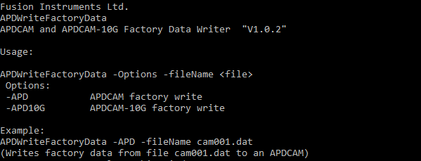

Argument list:

* **-APD**
* **-APD10G**
* **-fileName**

The arguments are very simple, **-APD** means that we are wanted to write any APDCAM. **–APD10G** means we are wanted to write an APDCAM-10G, **-fileName** is the path and file name for the file containing factory parameters.

If you are using the software with the correct parameters, you should see this.

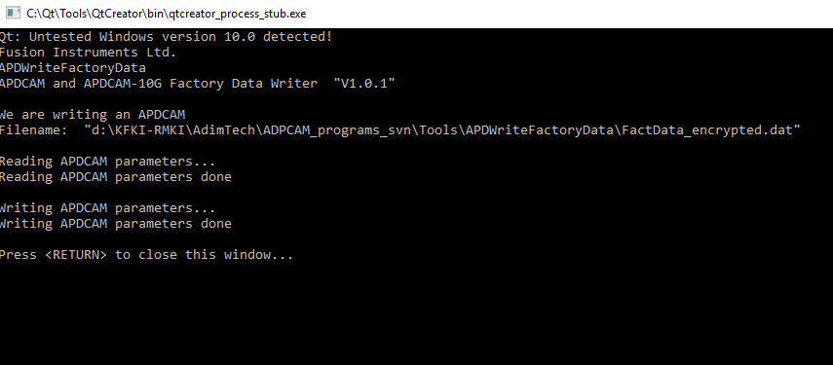

After this, your APDCAM factory table was filled successfully.

1. **Support**

If you have any further questions of want to report a bug please contact us by email:

[support@fusioninstruments.com](mailto:support@fusioninstruments.com?subject=APDWriteFactoryData)